Name ______________________________________________________________

2.2 Practice (Examples 1-5)

***Determine whether the given points are on the graph of the equation.***

1. Equation:  2. Equation: 

Points: (0,0), (1,1), (1,-1) Points: (0,2), (-2,2), 

***Graph each equation by plotting points.***

3.  4. 

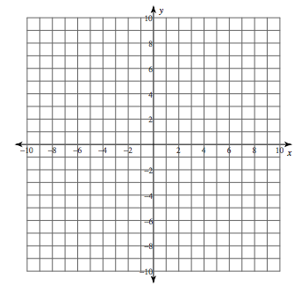

5.  6. 