Name ______________________________________________________________

2.2 Practice (Examples 6-7)

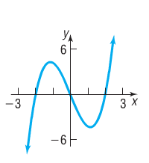

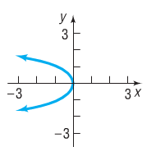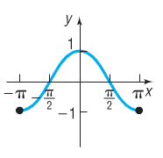***List the intercepts of the graph.***

1. 2. 3.

***Find the intercepts of the graphs, then graph by plotting points.***

4.  5. 

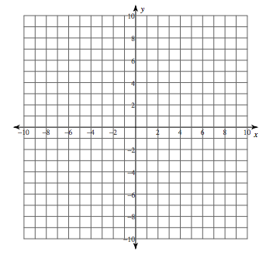

6.  7. 