Name ______________________________________________________________

3.2 Practice

***Determine whether the graph is that of a function by using the vertical-line test. If it is, use the graph to find:***

1. ***its domain and range***
2. ***the intercepts, if any***
3. ***any symmetry with respect to the x-axis, the y-axis, or the origin***

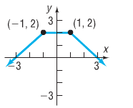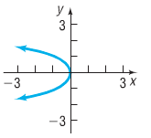1. 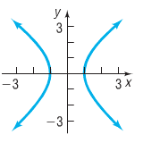 2. 3.

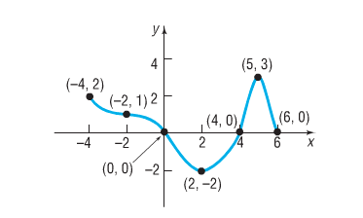

***Use the graph of the function f given below to answer parts (a)-(n).***

4.

a) Find *f(0)* and *f(6).*

b) Find *f(2)* and *f(-2).*

c) Is *f(3)* positive or negative?

d) is *f(-1)* positive or negative?

e) For what numbers is *f(x)=0*?

f) For what numbers is *f(x)<0*?

g) What is the domain of *f*?

h) What is the range of *f*?

i) What are the x-intercepts?

j) What is the y-intercept?

k) How often does the line *y=-1* intersect the graph?

l) How often does the line *x=1* intersect the graph?

m) For what value of *x* does *f(x)=3*?

n) For what value of *x* does *f(x)=-2*?

***In problems 5-7, answer the questions about the given function.***

5. $f\left(x\right)=-3x^{2}+5x$

a) Is the point (-1,2) on the graph of *f*?

b) If *x=-2*, what is *f(x)*? What point is on the graph of *f*?

c) If *f(x)=-2*, what is *x*? What point(s) are on the graph of *f*?

d) What is the domain of *f*?

e) List the x-intercepts, if any, of the graph of *f*.

f) List the y-intercept, if there is one, of the graph of *f*.

6. $f\left(x\right)=\frac{x^{2}+2}{x+4}$

a) Is the point (1,3) on the graph of *f*?

b) If *x=0*, what is *f(x)*? What point is on the graph of *f*?

c) If *f(x)=1/2*, what is *x*? What point(s) are on the graph of *f*?

d) What is the domain of *f*?

e) List the x-intercepts, if any, of the graph of *f*.

f) List the y-intercept, if there is one, of the graph of *f*.

7. $f\left(x\right)=\frac{2x}{x-2}$

a) Is the point $\left(\frac{1}{2},-\frac{2}{3}\right)$ on the graph of *f*?

b) If *x=4*, what is *f(x)*? What point is on the graph of *f*?

c) If *f(x)=1*, what is *x*? What point(s) are on the graph of *f*?

d) What is the domain of *f*?

e) List the x-intercepts, if any, of the graph of *f*.

f) List the y-intercept, if there is one, of the graph of *f*.

8. The last player in the NBA to use an underhand foul shot (a “granny” shot) was Hall of Fame forward Rick Barry who retired in 1980. Barry believes that current NBA players could increase their free-throw percentage if they were to use an underhand shot. Since underhand shots are released from a lower position, the angle of the shot must be increased. If a player shoots an underhand foul shot, releasing the ball at a 70-degree angle from a position 3.5 feet above the floor, then the path of the ball can be modeled by the function $h\left(x\right)=-\frac{136x^{2}}{v^{2}}+2.7x+3.5$, where *h* is the height of the ball above the floor, *x* is the forward distance of the ball in front of the foul line, and *v* is the initial velocity with which the ball is shot in feet per second.

a) The center of the hoop is 10 fee above the floor and 15 feet in front of the foul line. Determine the initial velocity with which the ball must be shot in order for the ball to go through the hoop.

b) Write the function for the path of the ball using the velocity found in part a).

c) Determine the height of the ball after is has traveled 9 feet in front of the foul line.

9. ***Match each function with the graph that best describes the situation. Discuss the reason for your choice.***

a) The temperature of a bowl of soup as a function of time

b) The number of hours of daylight per day over a 2-year period

c) The population of Florida as a function of time

d) The distance of a car traveling at a constant velocity as a function of time

e) The height of a golf ball hit with a 7-iron as a function of time

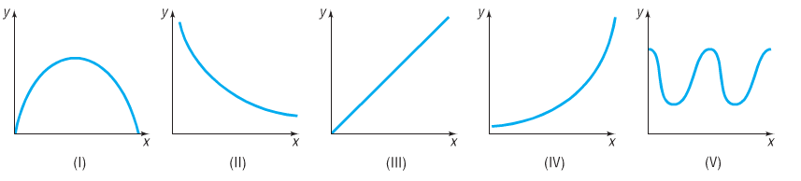

10. Consider the following scenario: Jayne enjoys riding her bicycle through the woods. At the forest preserve, she gets on her bicycle and rides up a 2000-foot incline in 10 minutes. She then travels down in incline in 3 minutes. The next 5000 feet is level terrain and she covers the distance in 20 minutes. She rests for 15 minutes. Jayne then travels 10,000 feet in 30 minutes. Draw a graph of Jayne’s distance traveled (in feet) as a function of time.

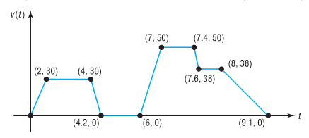11. The following sketch represents the speed *v* (in miles per hour) of Michael’s car as a function of time *t* (in minutes).

a) Over what interval of time is Michael

traveling fastest?

b) Over what interval(s) of time is Michael’s

speed zero?

c) What is Michael’s speed between 0 and 2 minutes?

d) What is Michael’s speed between 4.2 and 6 minutes?

e) What is Michael’s speed between 7 and 7.4 minutes?

f) When is Michael’s speed constant?