Name ______________________________________________________________

3.3 Practice

***In problems 1-3, the graph of a function is given. Use the graph to find:***

1. ***the intercepts, if any***
2. ***its domain and range***
3. ***the intervals on which it is increasing, decreasing, or constant***
4. 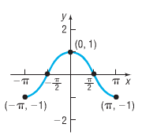***whether it is even, odd, or neither***

******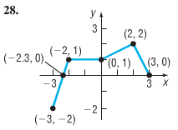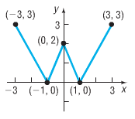

1. 2. 3.

***In problems 4-7, determine algebraically whether each function is even, odd, or neither.***

4. 5.

6. 7.

***In problems 8-17, use the graph of the function*** *f* ***given below.***

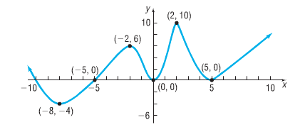

8. Is *f* increasing on the interval (-8,-2)?

9. Is *f* decreasing on the interval (-8,-4)?

10. Is *f* increasing on the interval (2,10)?

11. Is *f* decreasing on the interval (2,5)?

12. List the interval(s) on which *f* is increasing.

13. List the interval(s) on which *f* is decreasing.

14. Is there a local maximum at 2? If yes, what is it?

15. Is there a local maximum at 5? If yes, what is it?

16. List the numbers at which *f* has a local maximum. What are these local maxima?

17. List the numbers at which *f* has a local minimum. What are these local minima?

***In problems 18 & 19, the graph of a function*** *f* ***is given. Use the graph to find:***

1. ***the numbers, if any, at which f has a local maximum. What are these local maxima?***
2. ***the numbers, if any, at which f has a local minimum. What are these local minima?***

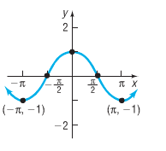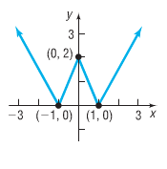18. 19.

***In problems 20-21, use a graphing utility to graph each function over the indicated interval and approximate any local maxima and local minima. Determine where the function is increasing and where it is decreasing.***

20. 21.

22. ***Find the average rate of change of :***

***a) From 0 to 2***

***b) From 1 to 3***

***c) From 1 to 4***

23. ***Find the average rate of change of $f\left(x\right)=-x^{3}+1$:***

***a) From 0 to 2***

***b) From 1 to 3***

***c) From -1 to 1***

***In problems 24-26, a) find the average rate of change from 1 to 3.***

***b) Find an equation of the secant line containing (1,f(1)) and (3,f(3)).***

24. 25. 26.