Name ______________________________________________________________

3.4 Practice

***In problems #1-4, a) graph each function, b) locate any intercepts, c) state the domain, d) state the range.***

1. 2.

3. 4.



***5. Graph $f\left(x\right)=int(2x)$***

***In problems #6-7, the graph of the piecewise-defined function is given. Write a definition for each function.***

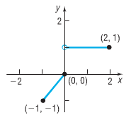6. 7. 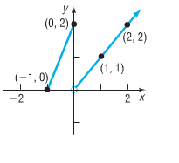

8. In May 2003, the Peoples Gas Company had the following rate schedule for natural gas usage in single-family residences:

Monthly service charge $9.45

Per them service charge:

1st 50 therms $0.36375/therm

Over 50 therms $0.11445/therm

Gas charge $0.6338/therm

***a) What is the charge for using 50 therms in a month?***

***b) What is the charge for using 500 therms in a month?***

***c) Construct a function that relates the monthly charge C for x therms of gas.***