Name ______________________________________________________________

4.3 Practice

***In problems #1-4, find the domain of each rational function.***

1.  2.  3.  4. 

***In problems, #5-7, graph each rational function using transformations.***

5.  6.  7. 

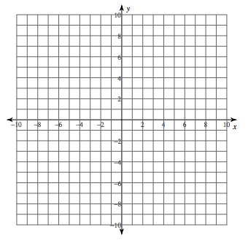

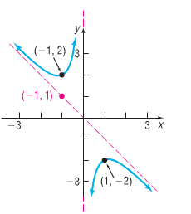***In problems #8-10, use the graph shown to find: a) the domain and range; b) vertical asymptotes, if any; c) horizontal asymptotes, if any; and d) oblique asymptotes, if any***

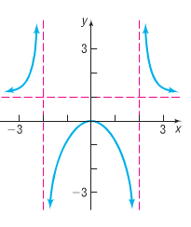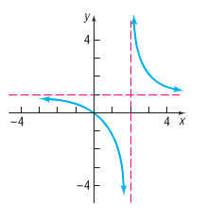8. 9. 10.

***In problems #11-15, find the vertical, horizontal, and oblique asymptotes, if any, of each rational function.***

11.  12.  13. 

14.  15. 